Bank Management System

Software Requirements Specification

19/10/2021

W. E. HOPE WANJA

Table of Contents

Software Requirements Specification 1

1.1 Purpose 2

1.2 Scope 2

1.4 References 2

2.1 Product Perspective 3

2.2 Product Functions 3

2.2.6 Aircraft Check­in 4

2.3 User Characteristics 4

2.4 General Constraints 5

2.5 Assumptions and Dependencies 5

3.1 External Interface Requirements 5

3. 3.1.1 User Interfaces 5

4. 3.1.2 Hardware Interfaces 5

5. 3.1.3 Software Interfaces 5

7. 3.1.4 Communications Interfaces 6

3.2 Functional Requirements 6

3.3 Use Cases 8

8. 3.3.1 Use Case #1 8

3.3.2 Use case #2 9

3.3.3 Use case #3 9

3.3.4 Use case #4 10

3.4 Classes / Objects 11

1. 3.4.1 Customer 11

1. 3.5.1 Performance 12

2. 3.5.2 Reliability 12

3. 3.5.3 Availability 12

5. 3.5.5 Maintainability 13

3.6 Inverse Requirements 13

3.8 Logical Database Requirements 13

3.9 Other Requirements 13

4.1 Sequence Diagrams 14

4.2 State­Transition Diagrams (STD) 18

1. 5. Change Management Process 19

# Introduction

## 1.1 Purpose

Online banking system provides is specifically developed for internet banking for Balance Enquiry. The Traditional way of maintaining details of a user in a bank was to enter the details and record them. Every time the user need to perform some transactions he has to go to bank and perform the necessary actions, which may not be so feasible all the time. It may be a hard-hitting task for the users and the bankers too. The project gives real life understanding of Internet banking and activities performed by various roles in the supply chain. Here, we provide an automation for banking system through Internet. Internet banking system project captures activities performed by different roles in real life banking which provides enhanced techniques for maintaining the required in­ formation up-to-date, which results in efficiency. The project gives real life understanding of Internet banking and activities performed by various roles in the supply chain.

## 1.2 Scope

This Product will automate of banking transaction process. This Project investigates the entry threshold for providing a new transaction service channel via the real options approach, where the entry threshold is established by using an Internet banking system designed for personal banking.

# General Description

## 2.1 Product Perspective

The client will have client interface in which he can interact with the banking sys­ tem. It is a web based interface which will be the web page of the banking application. Starting a page is displayed asking the customer to create an account. Then the page is redirected to login page where the user can enter the login details. If the login particulars are valid then the user is taken to the transaction segment. All the above activities come under the client interface.

The administrator will have an administrative in­ terrace which is a GUI so that he can view the entire system. He will also have a login page where he can enter the login particulars so that he can perform all his actions. This administrative interface provides different environment such that he can maintain data­ base & provide backups for the information in the database. He can register the users by providing them with username, password & by creating account in the database. He can view the cheese book request & perform action to issue the cheque books to the clients.

## 2.2 Product Functions

This section provides the functional overview of the product. The project will require the JAVA as a front end and at the back end.

1. Login
2. Validation
3. Get balance information
4. Withdrawal of money

6. Customer info.

## 2.3 User Characteristics

For you to access any information in the bank you must have the needed credentials in each page

* Account number
* password

## 2.4 General Constraints

1. The information of all the users must be stored in a database that is accessible by the On­ line Banking System.
2. The Online Banking System is connected to the computer and is running all 24hours a day.3) The users access the Online Banking System from any computer that has Internet browsing capabilities and an Internet connection.

4) The users must have their correct usernames and passwords to enter into the Online Banking System.

## 2.5 Assumptions and Dependencies

* All users are assumed to be equipped with GUI terminals.
* All master data entry will be undertaken jointly by RMA.
* All CAM users have undergone user training.
* Reports which are not freeze must be freeze before the completion of High level design.
* All the data requirement section given in all process will be given during the High level design stage
* Input parameters for report needs further discussion with the end users.
* 3. Specific Requirements

## 3.1 External Interface Requirements

### 3. 3.1.1 User Interfaces

• The system shall provide a help (explanation) to Customer that how to use particular System.

### 4. 3.1.2 Hardware Interfaces

Various interfaces for the product could be

1. Touch screen/Monitor
2. Keypad
3. Continuous battery backup
4. Printer which can produce the hard copy.
5. Interface that connects the device to bank’s computer.
6. An interface that can count currency notes.

### 5. 3.1.3 Software Interfaces

6. 1. Any windows operating system.

1. The JAVA, jdk, NetBeans must be installed. These products are open source products.
2. The final application must be packaged in a set up program, so that the products can be easily installed on machines. This application must be networked to corresponding banks.

### 7. 3.1.4 Communications Interfaces

* Customer should ask clerk to confirm the acceptance of Account signature.
* Customer should submit slip to the clerk for transaction.

## 3.2 Functional Requirements

The details of the functionalities and major use case covered in the CAM module are for basic account management

* Creation
* Transfer funds
* Withdraw funds
* Check balance
* Deposit funds
* Close account

## 3.3 Use Cases

### 8. 3.3.1 Use Case #1

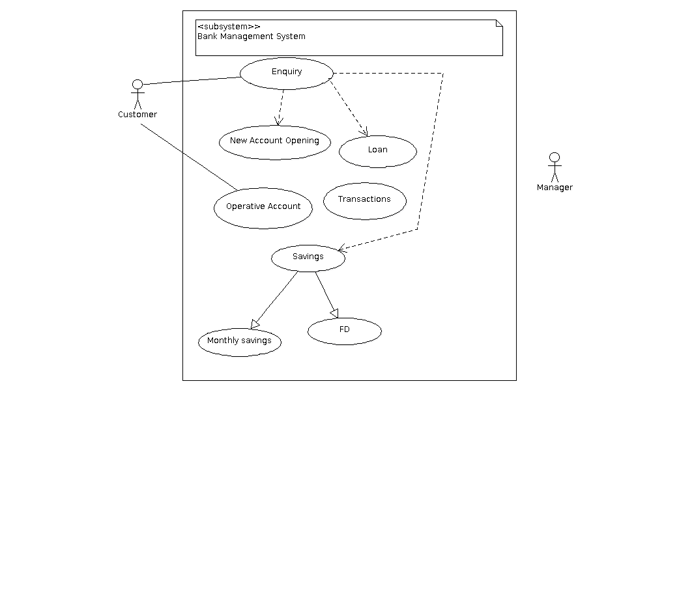

### 3.3.2 Use case #2

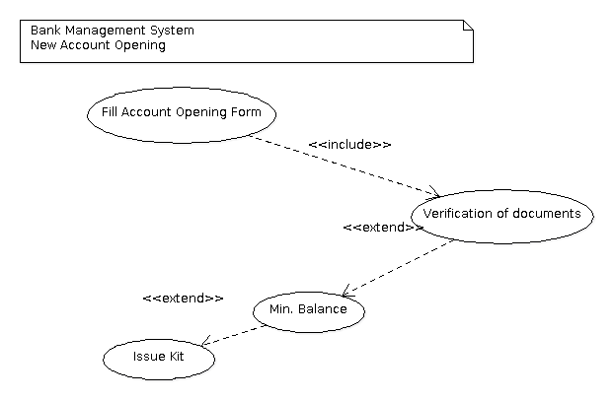

### 3.3.3 Use case #3

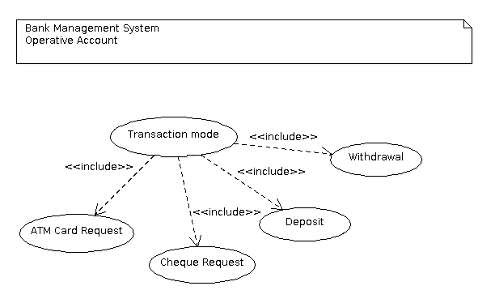

### 3.3.4 Use case #4

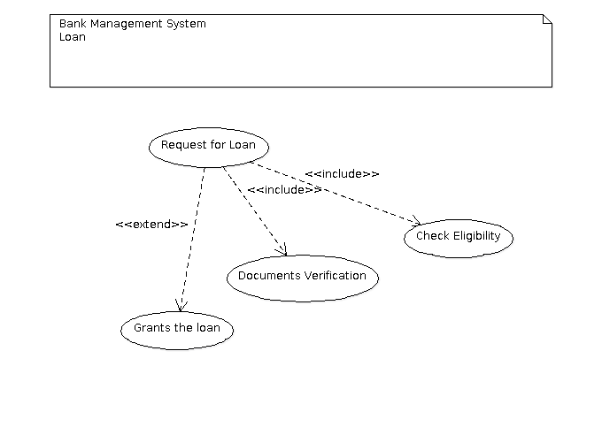

## 3.4 Classes / Objects

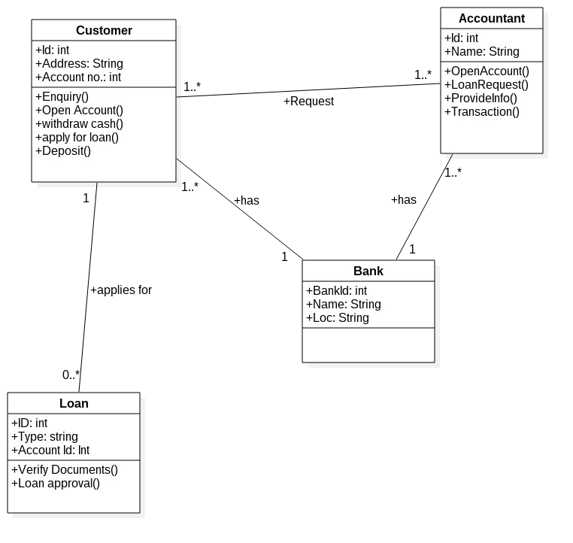

### 1. 3.4.1 Customer

3.4.1.1. Attributes:

1. ID
2. Account No.

3.4.1.2. Functions:

1.Open Account

2.Withdraw Cash

3.Apply for loan

4.Deposit

#### 3.4.2 Accountant

3.4.2.1. Attributes:

1.ID

2.Name

3.4.2.2. Functions:

1.Enquiry 2. Loan Request

3.Provide Info.

4.Transaction

#### 3.4.3 Bank

3.4.3.1. Attributes:

1.BankID

2.Name

1. Lock

3.5 Nonfunctional Requirements.

### 1. 3.5.1 Performance

* The system shall update all accounts information after every transaction
* Responses to queries shall take no longer than 10 seconds to load onto the screen after the user payment is in Process.

### 2. 3.5.2 Reliability

* The User Verification process should access the database faster and Confirmation message must be display.
* No breakdown of server problems and accounts status should not be delayed.

### 3. 3.5.3 Availability

• Availability to seek help from any staff should be Provided.

4. 3.5.4 Security:

* The user details inside the database must be safe and should be produce whenever necessary.
* The confirmation message after payment must be safely send to customer emails.

### 5. 3.5.5 Maintainability

* The customer details inside the database must be safely maintained.
* The details of transaction must be maintained.

## 3.6 Inverse Requirements

*No Inverse Requirements.* 3.7 Design Constraints

*No Design Constraints.*

## 3.8 Logical Database Requirements

* REQ-LD1: The database backend system in use will be Oracle 10i.
* REQ-LD2: The Front-end and middle logic will be written using Janae.
* REQ-LD3: Code will be stored on the Google Code SVN repository.

[http://code.google.com/p/afirs/]

* REQ-LD4: Our development environment will be the latest NetBeans Integrated Development Environment.
* REQ-LD5: We will use Apache as our web server.
* REQ-LD6: We may write scripts to create synthetic code in Python/Perl.
* REQ-LD7: We may make changes to any of the above system requirement at any time and for any reason

## 3.9 Other Requirements

*Catch all section for any additional requirements.*

6. 4. Analysis Models

## 4.1 Sequence Diagrams

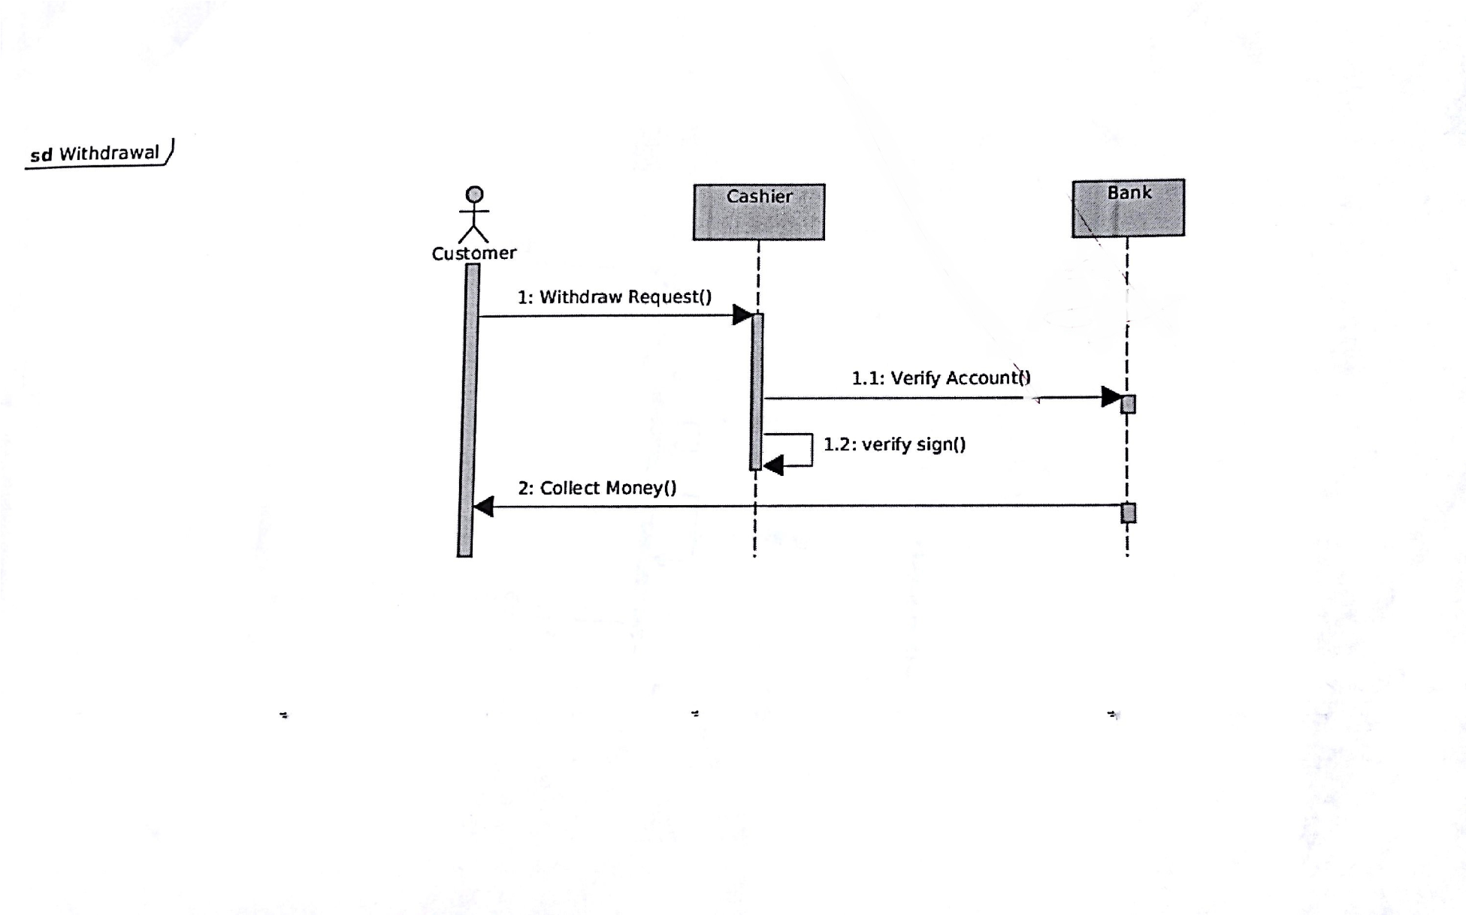

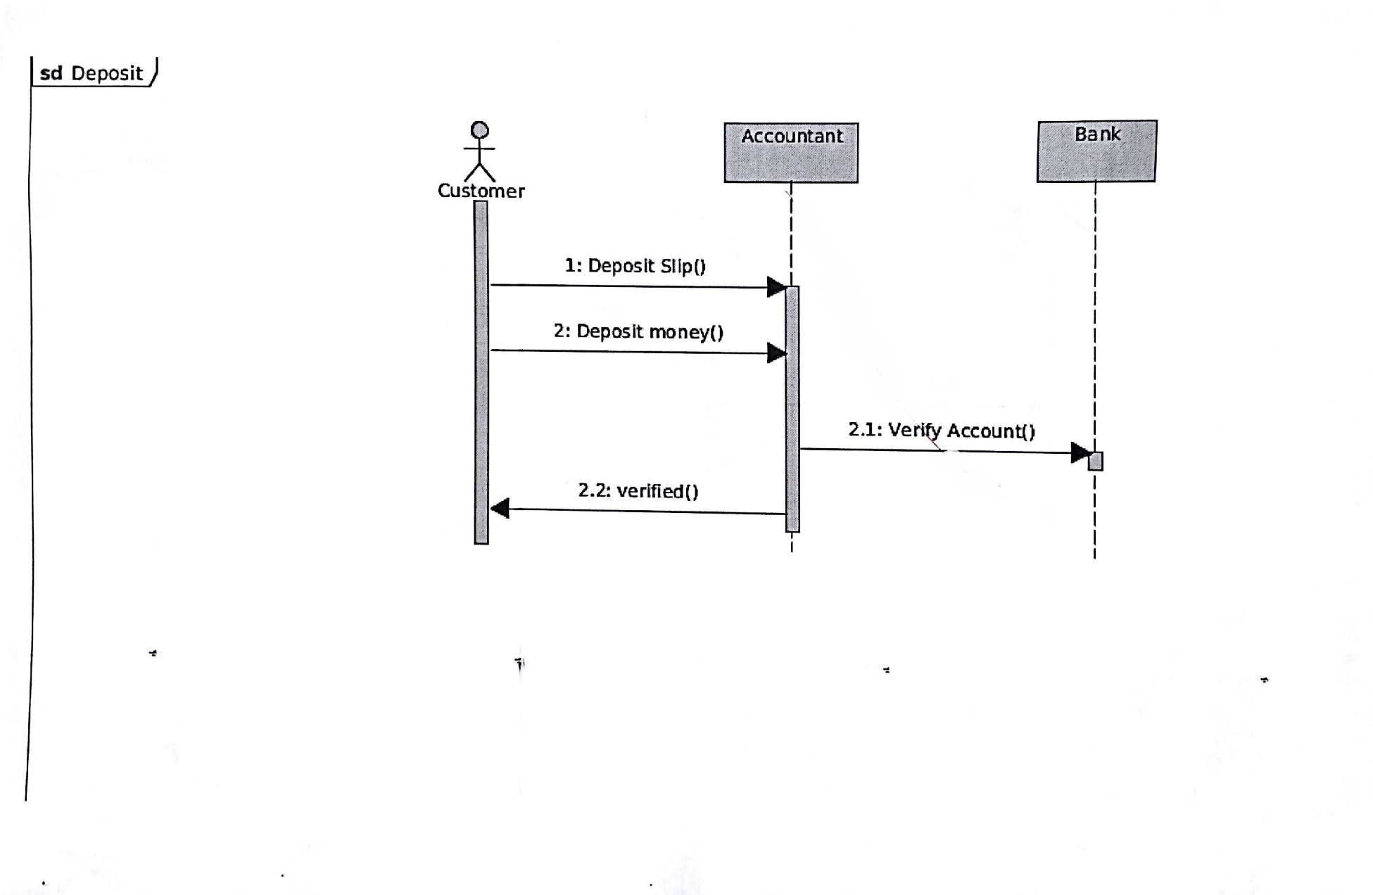

4.3 Data Flow Diagrams (DFD)

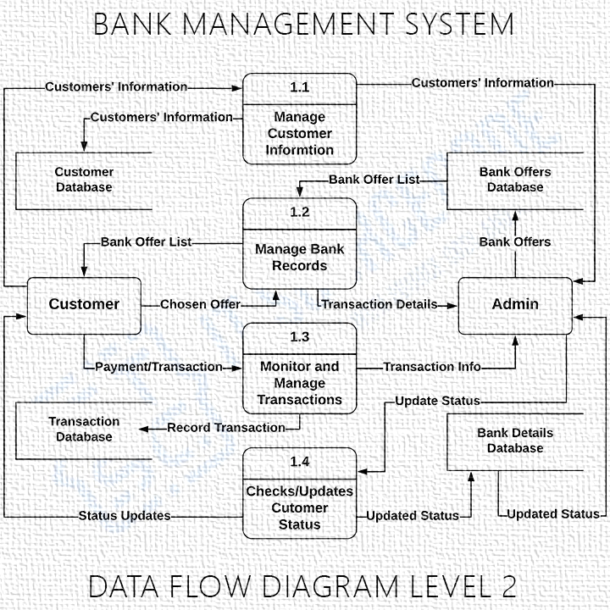

## 4.2 State Transition Diagrams (STD)

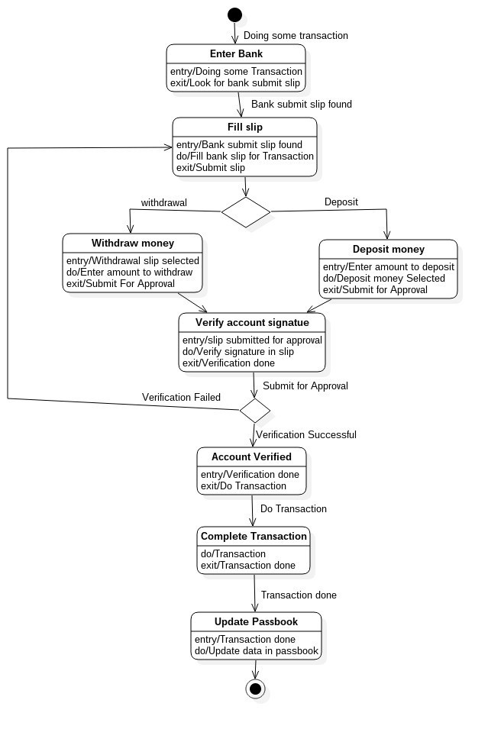

### 1. 5. Change Management Process

*Identify and describe the process that will be used to update the SRS, as needed, when project scope or requirements change. Who can submit changes and by what means, and how will these changes be approved.*